**Introducing DS18B20 Temperature Sensor**

The [DS18B20 temperature sensor](https://makeradvisor.com/tools/ds18b20-temperature-sensor-2/) is a one-wire digital temperature sensor. This means that it just requires one data line (and GND) to communicate with your ESP32.

It can be powered by an external power supply or it can derive power from the data line (called “parasite mode”), which eliminates the need for an external power supply.

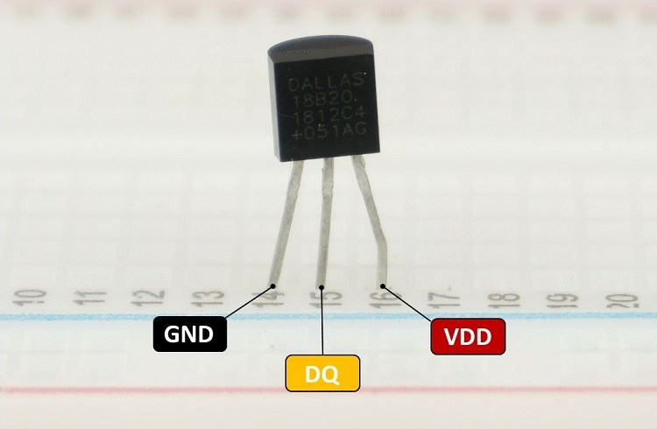

Each DS18B20 temperature sensor has a unique 64-bit serial code. This allows you to wire multiple sensors to the same data wire. So, you can get temperature from multiple sensors using just one GPIO.

The DS18B20 temperature sensor is also available in [waterproof version](https://makeradvisor.com/tools/ds18b20-digital-temperature-sensor/).

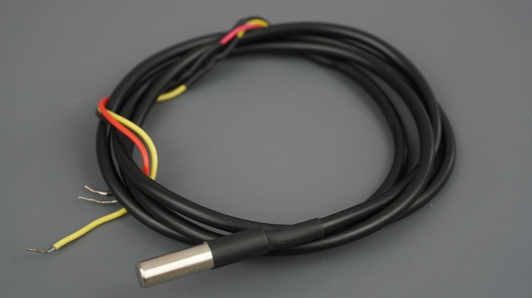

Here’s a summary of the most relevant specs of the DS18B20 temperature sensor:

* Communicates over one-wire bus communication
* Power supply range: 3.0V to 5.5V
* Operating temperature range: -55ºC to +125ºC
* Accuracy +/-0.5 ºC (between the range -10ºC to 85ºC)

## Schematic – ESP32

As mentioned previously, the DS18B20 temperature sensor can be powered through the VDD pin (**normal mode**), or it can derive its power from the data line (**parasite mode**). You can chose either modes.

### Normal Mode

[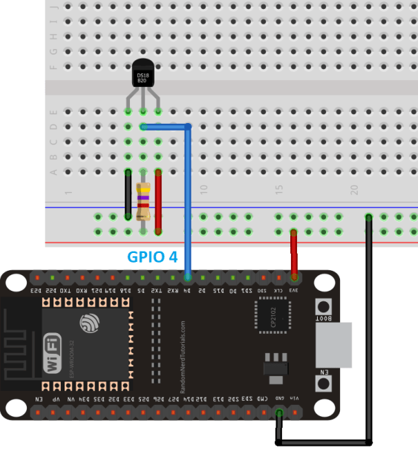](https://i0.wp.com/randomnerdtutorials.com/wp-content/uploads/2019/06/ds18b20_esp32_single_normal.png?quality=100&strip=all&ssl=1)

### Parasite Mode

[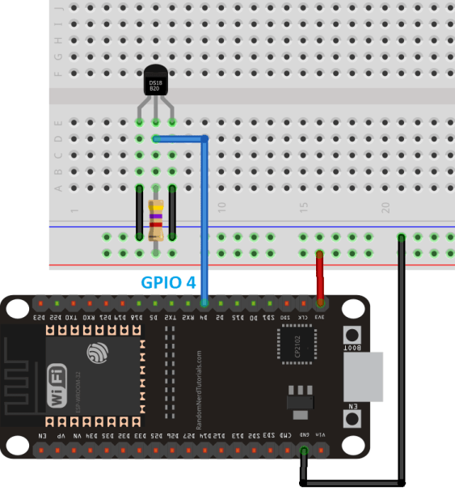](https://i0.wp.com/randomnerdtutorials.com/wp-content/uploads/2019/06/ds18b20_esp32_single_parasite_bb.png?quality=100&strip=all&ssl=1)

## Preparing Your Arduino IDE

We’ll program the ESP32 using Arduino IDE, so make sure you have the ESP32 add-on installed before proceeding:

* [Install ESP32 Board in Arduino IDE (Windows, Mac OS X, and Linux instructions)](https://randomnerdtutorials.com/installing-the-esp32-board-in-arduino-ide-windows-instructions/)

Installing Libraries

To interface with the DS18B20 temperature sensor, you need to install the [One Wire library by Paul Stoffregen](https://github.com/PaulStoffregen/OneWire) and the [Dallas Temperature library](https://github.com/milesburton/Arduino-Temperature-Control-Library). Follow the next steps to install those libraries.

1. Open your Arduino IDE and go to **Sketch**> **Include Library** > **Manage Libraries**. The Library Manager should open.

2. Type “**onewire**” in the search box and install OneWire library by Paul Stoffregen.

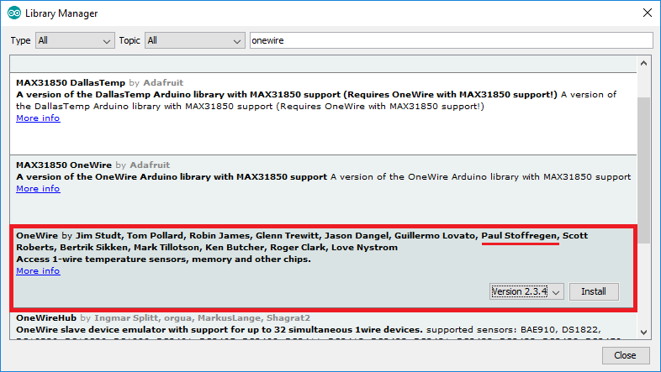

3. Then, search for “**Dallas**” and install DallasTemperature library by Miles Burton.

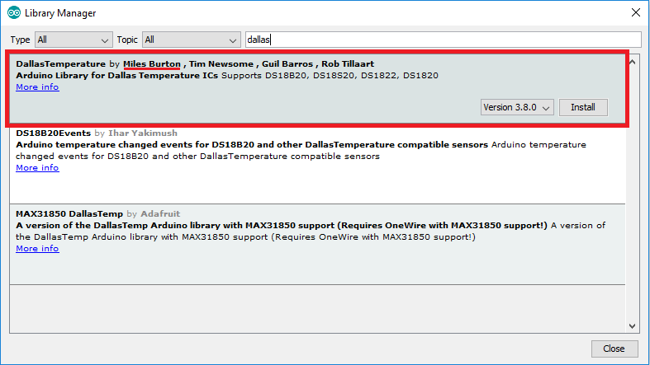

After installing the libraries, restart your Arduino IDE.